**Stakeholder Information**

**Activity Description**

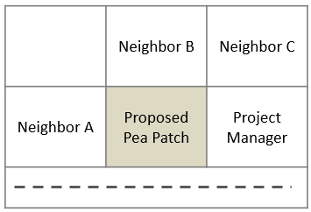The city has allocated funds for Community Pea Patches to be developed in neighborhoods throughout the city, and one of your neighbors submitted an application for a vacant lot that is for sale to be purchased and developed as a community garden. For the application to be approved by the City Coordinator, the community must be supportive of the project. Assess the ‘feelings’ of each of the stakeholders on this project as shown below:

* how you feel about the project,
* what role you will be playing,
* what expectations you have for the project, and
* what a successful conclusion looks like to you.

|  |  |  |  |  |  |
| --- | --- | --- | --- | --- | --- |
| Role | Posture Towards Project | Role  on Project | Project  Expectations | What Success  Looks Like | Relationship |
| *1. City Coordinator* | Neutral­­—more applicants than funds available | Job is to approve project and provide funding | Compliance to application process and contract, timely completion | No formal complaints or lawsuits from neighbors | Friends with Neighbor C |
| *2. Garden Store Owner* | Advocate—wants to create customers | Promoted the project, provides advice, sells product | Neighbors will shop locally at my store | Healthy community garden promotes more business | Good Friends with Neighbor C |
| *3. Neighbor A* | Advocate—loves the idea and already planning which veggies to grow | Willing to volunteer to help build garden, wants to be a garden patron | Wants to know how to help and when | Health community garden with lots of neighbor activity and sense of connection | Really good relationship with PM |
| *4. Neighbor B* | Against—Doesn’t want noise/parking issues associated with pea patch | Actively against project, reviewing rules, threatening legal action | For project to not go forward—wants to be informed of process | No community pea patch and house remain vacant – less noise, parking issues | Really good relationship with Neighbor C |
| *5. Neighbor C* | Neutral—Doesn’t want McMansion developed on lot, doesn’t want stench of “compost heap next door” either | Interested in outcome and in guarantees of use as intension, as well as other options | Expects to be made aware of decisions and safeguards / contingency plans | Either a vibrant, moderately used garden or a new moderate home is developed on land | Friendly with all except doesn’t know A |